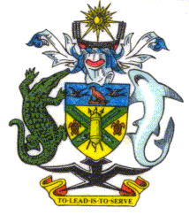

NATIONAL PARLIAMENT OF SOLOMON ISLANDS

FOREIGN RELATIONS COMMITTEE

Program for the
Foreign Relations Committee’s Inquiry into and Review of the Facilitation of International Assistance Notice 2003

Wednesday 12 – 14 November 2008

House of Glory Aligegeo
09:00 a.m. Committee Members, Secretariat and technical support staff arrive at House of Glory, Aligegeo
WEDNESDAY12

09:30 – 10:00 a.m. Staff, students, invited guests and members of the public take their designated seats in and around the Assembly Hall; support staff finalize setting up the Hall.

10:00 a.m. Program commences:

Opening Prayer – Pastor David

Welcome – Pastor David

Village choir

Opening Address – Clerk (MC)

Chair and Committee Members take their seats
Hearing proper commences:

Chair’s Opening Statement

