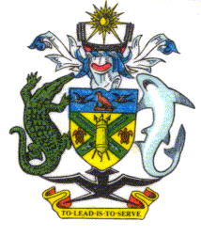 | PUBLIC ACCOUNTS COMMITTEE
 | NATIONAL PARLIAMENT OF SOLOMON ISLANDS

Minutes of Proceedings

Head 271: Office of the Auditor General

Meeting No. 2

Monday 10 March, 2008, Parliament House, 2:30 pm

1. Members Present
Hon. Francis Zama (Chair), MP
Hon. Manasseh Sogavare, MP
Hon. Clay Soalaoi, MP
Hon. Mark Kemakeza, MP
Hon. Trevor Olavae, MP

Witnesses
Mr. Floyd Augustine Fatai, (Secretary) Auditor
Ms. Michelle Maschmedt, Advisor, Office of the Auditor General
Mr. Walter Malau, Senior Auditor, Office of the Auditor General

Secretariat
Mr. Jude S Devesi, Committee Secretariat, Clerk to the PAC
Ms. Alice Willy, Committee Secretariat. Clerk to Inquiry

In Attendance
Mr. Ben Mendo, CAO Establishments, Public Service

2. Inquiry into the 2008 Budget Estimates
The Auditor General and Officers of the Office of the Auditor General appeared before the Committee.

The Chair welcomed the Auditor General and asked the Auditor General to deliver his opening statement.

The Committee heard a briefing from Mr. Fatai (Auditor General)

The Committee questioned the Auditor General and his Officers.

Evidence concluded.

The Committee deliberated and resolved that the Office of the Auditor General provide to the committee with their Strategic Plan 2008.

3. Close
The meeting closed at 3:30 pm.

