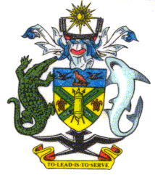 | PUBLIC ACCOUNTS COMMITTEE
 | NATIONAL PARLIAMENT OF SOLOMON ISLANDS

Minutes of Proceedings

Head 275: Office of the Governor General

Meeting No. 3

Monday 10 March, 2008, Parliament House, 3:30 pm

1. Members Present
Hon. Francis Zama (Chair), MP
Hon. Manasseh Sogavare, MP
Hon. Clay Soalasi, MP
Hon. Mark Kemakeza, MP
Hon. Trevor Olavae, MP

Witness
Mr. Nigel Maezama, Secretary to the Governor General

Secretariat
Mr. Floyd Augustine Fatai, (Secretary) Auditor General
Mr. Walter Malau, Senior Auditor, Office or the Auditor General.
Mr. Jude S Devesi, Committee Secretariat, Clerk to Inquiry
Ms. Alice Willy, Committee Secretariat, Clerk to Inquiry

In Attendance
Mr. Warren Cahill, Parliamentary Strengthening Project
Ms. Florence Naesol, Deputy Clerk to Parliament
Mr. Mr. Ben Mendo, CAO Public Service
Ms. Michelle Maschmedt, Advisor, Office of the Auditor General

2. Inquiry into the 2008 Budget Estimates

The Secretary to the Governor General appeared before the Committee.

The Chair welcomed the Secretary to the Governor General and asked the Secretary to deliver his opening statement.

The Committee questioned the Secretary to the Governor General.

Evidence concluded.

The Committee deliberated.

3. Close
The meeting closed at 4:50 pm.

